React

React is one of the best JavaScript library to build web application. React is based on (JSX) JavaScript XML. It is pretty much simple and same as like a html but you can make dynamic according to the condition.

React works on Virtual DOM to make performance. So, that only particular parts of UI will change where it is needed.

Example of JSX

**return(**

**<div>   
 <div>Passed : {isPassed ? “Yes” :”No”}</div>  
</div>**

**)**

**Here, suppose isPassed is variable which hold Boolean value and it is making condition to print either “Yes” or “No”. It is much similar with html**

**Installation**

**You are required to install Node JS from** [**https://nodejs.org/en**](https://nodejs.org/en) **. Once you complete the installation . In your command prompt**

* **npx create-react-app state**

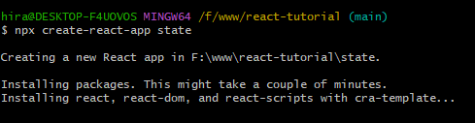

**Here, we are preparing installation for the “state” web application on F:\www\react-tutorial folder. You can install your app on any folder. There, is not mandatory to install react app at certain location or drive. While installing it will little bit time according to the performance of your computer.**

**Once complete the installation you will be successful message**

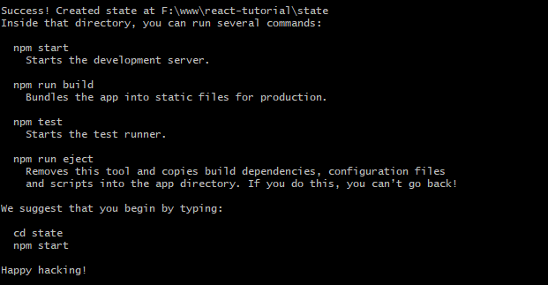

* **cd state**
* **npm start**

**Once you do npm start it will run application**

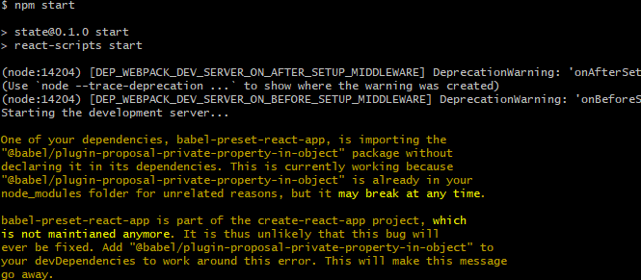

**Application will automatically open your browser with the location of localhost:3000**

